Power BI
1.data cleaning-
Data cleaning is the process of identifying and correcting (or removing) inaccurate, incomplete, duplicate, inconsistent, or irrelevant data from a dataset to improve its quality before analysis or modeling.
Common Data Cleaning Steps
1.Handle missing values
2.Remove duplicate records
3. Correct inconsistent data
4. Fix data types
5. Validate data etc.
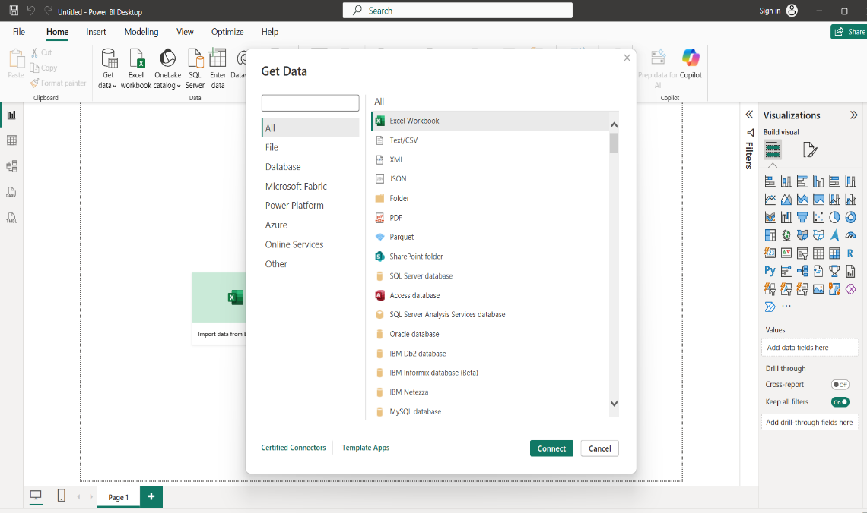
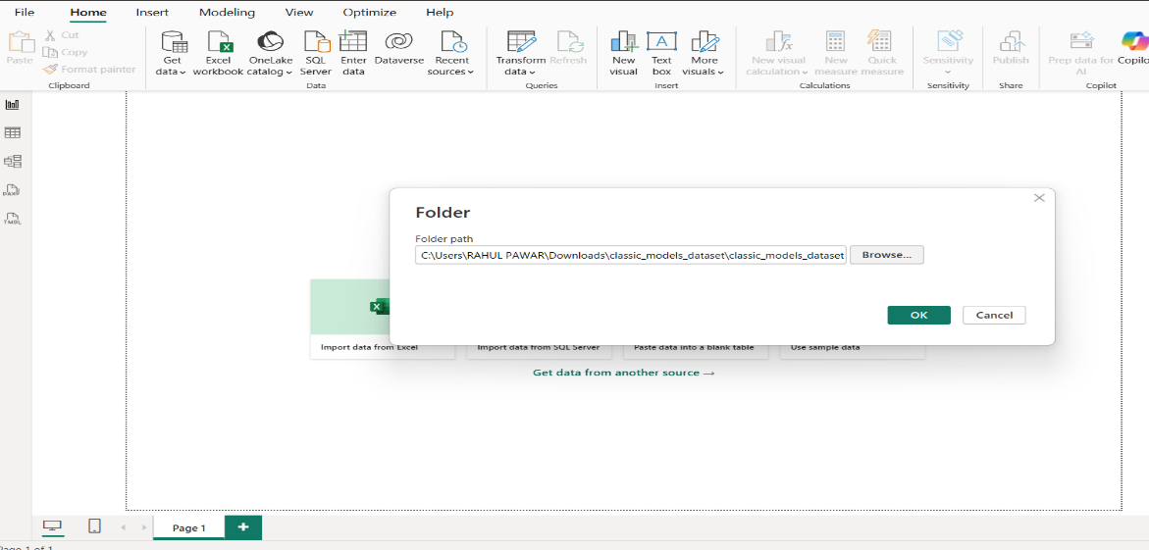
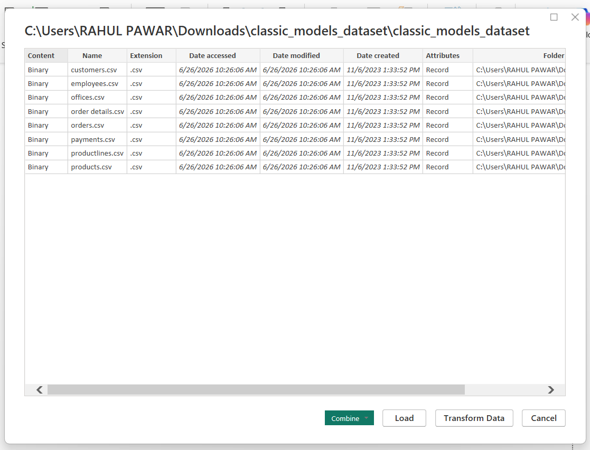
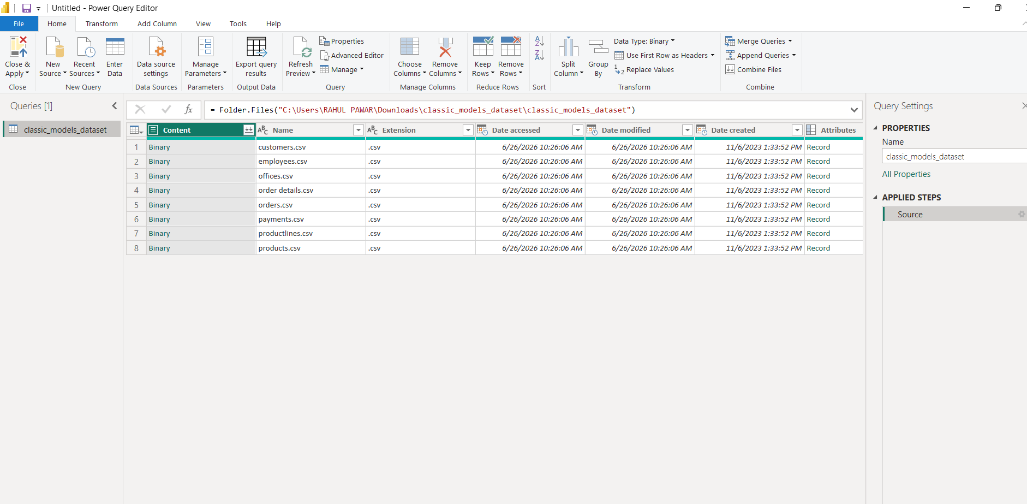
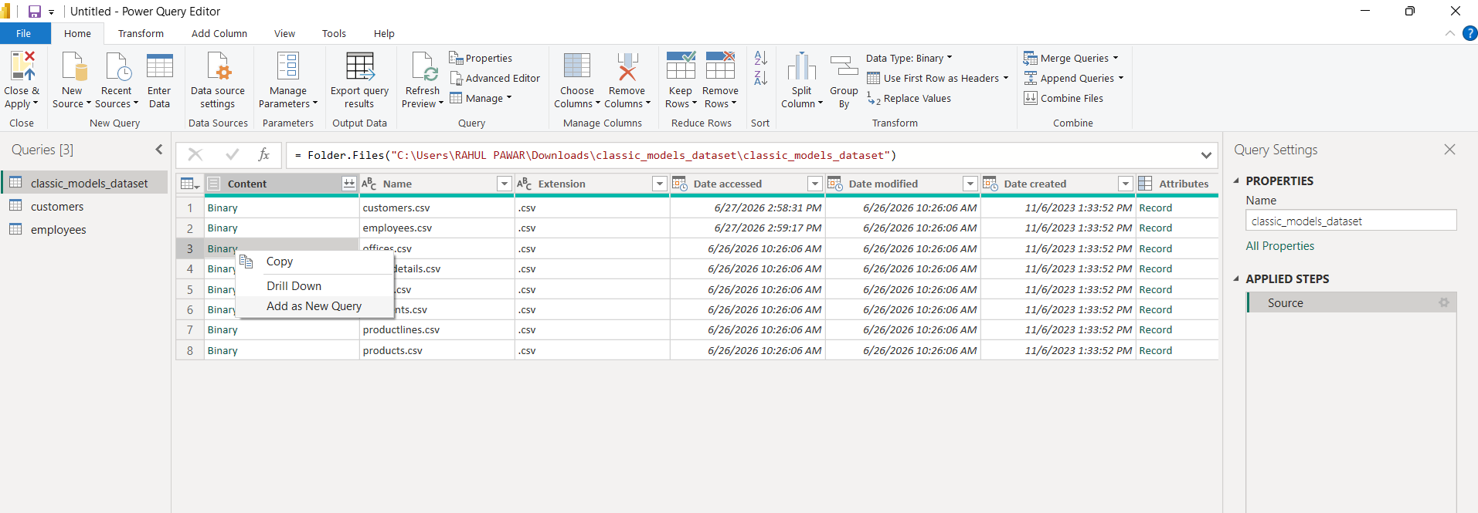
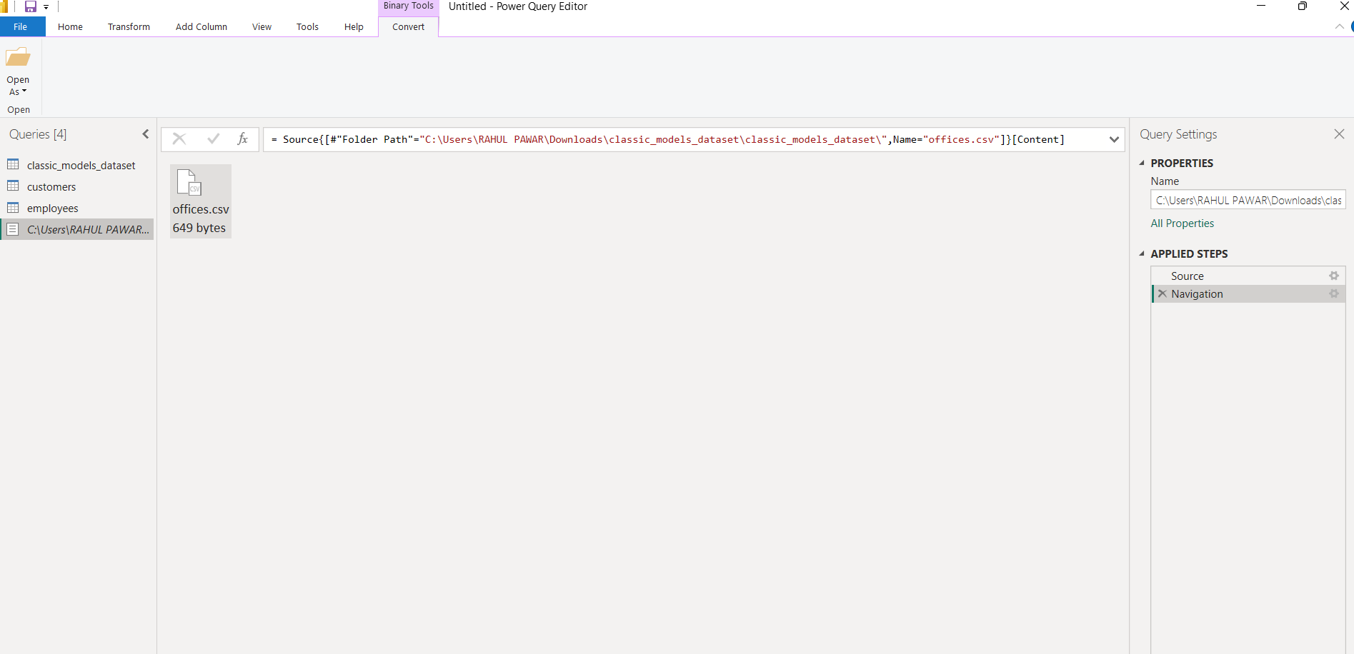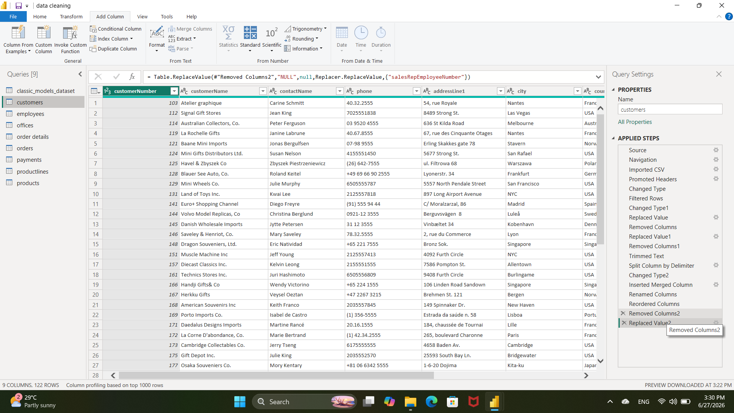
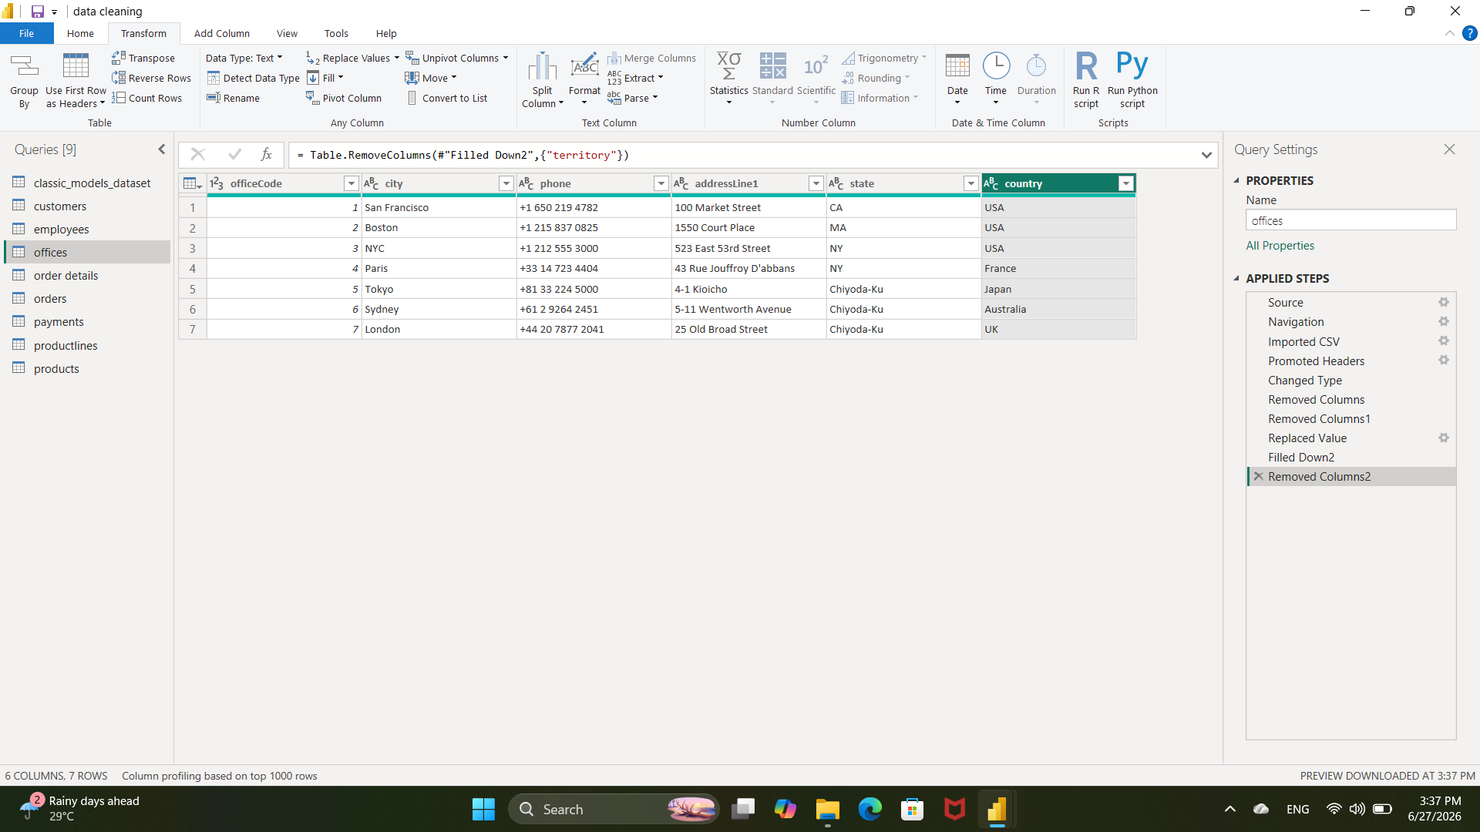
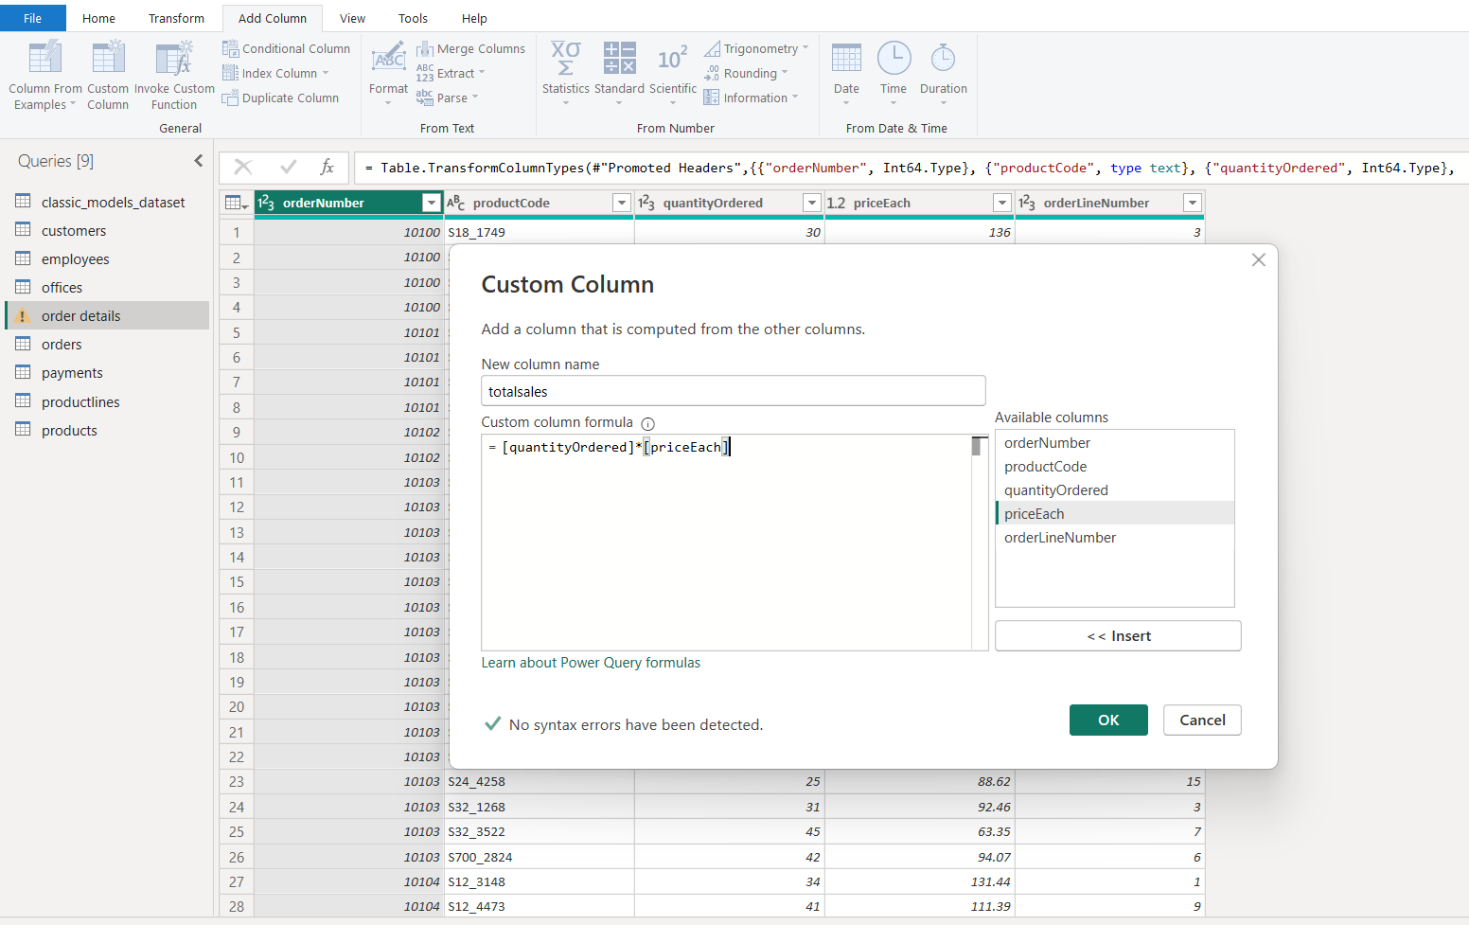
S